Date: JUN 04 2021 File: C:\Karapetyan\18556 Заявка на резку, нержавейка 2.5мм\03_program\2.5\18556_2.5001.NST

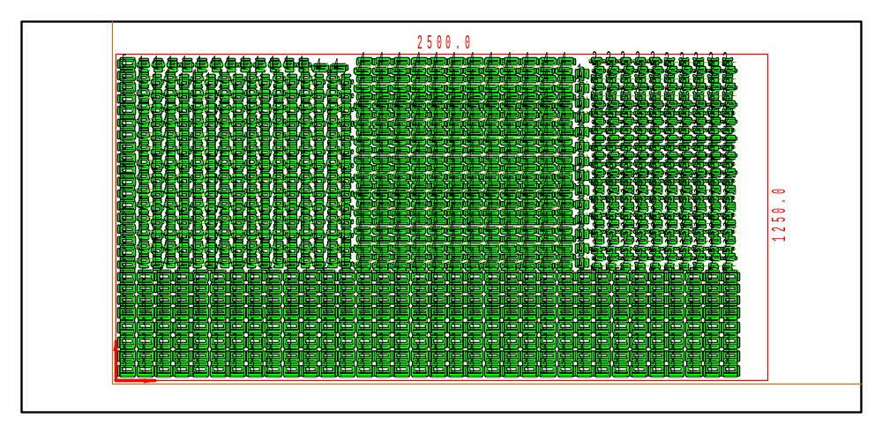

PART INFO
NC File Name: Ê!Å;Ä2WÅ6_2.5001%ËÍ
Draft no.: | Version:
Order no.: | Description:
SHEET Number of sheets: 1
Material: Stainless | Sheet size: 2500 X 1250 | T= 2.5
No. of parts: 1080 | Part size:
Part weight: | Sheet weight: 60.94 kg
MACHINE:
MODEL: ML3015EX |  | Con. name: SUS304 |  | Table name: ML45CF_R_EX
Gas: N2H | Lens: 7.5 Inches |  | Nozzle diameter: 1.7
Speed: 4000 |  | Used laser power: 4500 |  | Beam diameter (kerf): 0.32
PROGRAM
Number: 4173 | File size: 96866 | Programmer:
Notes:
JOB TIME (min:sec)
Travel: 11:49 | Cut: 84:31 | Pierce: 50:44
Travel way: 177325.1 mm | Cutting way: 0 mm | Pierce Qty.: 2580
Total time: 147:05

 | Part name | DX | DY | QTY
3 | Ê#Å;BF47SÌseriesÌ-Ìbottom^ËÍ | 60 | 45.3 | 170
5 | Ê#Å;BF47SsmallÌseriesÌ-ÌbottomIËÍ | 60 | 35.3 | 120
1 | Ê#Å;BF28SÌkeyÌ-ÌbottomzËÍ | 45.8 | 43.6 | 250
4 | Ê#Å;BF47SÌseriesÌ-Ìtop\ËÍ | 60 | 25.9 | 290
2 | Ê#Å;BF28SÌkeyÌ-ÌtopMËÍ | 45.8 | 24.8 | 250

